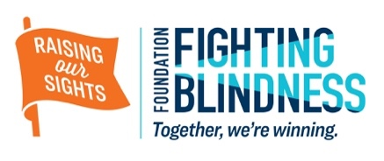

Dear [NAME OF DONOR],

Thank you so much for supporting my efforts to raise critical funds for the Foundation Fighting Blindness. Your gift of [$ DONATION AMOUNT] encouraged me to do my very best to ensure we raised money and awareness for the Foundation’s ground-breaking work to end blinding retinal diseases.

Together, we are bringing the Foundation Fighting Blindness one step closer to the finish line — cures to restore vision or prevent vision loss for people living with age-related macular degeneration or inherited retinal diseases. We believe it’s possible in our lifetime — in fact, the Foundation is funding treatments that have restored vision in patients who were virtually blind from a childhood form of retinitis pigmentosa.

Until we can help everyone affected by blinding retinal diseases — 10 million Americans and millions more around the world — we simply cannot stop.

Being a part of the fight against blinding retinal diseases has been a rewarding experience, made all the better by your support. [Personal reflection on your fundraising efforts — how your run, golf event, dinner, etc. went and any anecdotes from the day.]

In total, I raised [TOTAL FUNDRAISING DOLLARS] for the Foundation Fighting Blindness, and you made it all possible. Thank you.

Sincerely,
[YOUR NAME]

